ExpertBells Errors

High Priority

1) Website Loading Speed
Need To Work on Core Web Vitals {Loading Speed}
Both Mobile & Desktops
Home Page: https://www.expertbells.com/
Mobile: 51
Desktop: 79
Source: https://pagespeed.web.dev/analysis/https-www-expertbells-com/zt8rxx0h1c?form_factor=desktop

  - Loading Speed Issue On Service & Mentor Page
Need To Work on Core Web Vitals
Service Page: https://expertbells.com/service/private-limited-company-registrations
Mobile: 42
Source:
https://pagespeed.web.dev/analysis/https-expertbells-com-service-private-limited-company-registrations/msru9yo5ko?form_factor=mobile

-=-=-=-=-=-=-=-=-
2) URL Canonicalization Issue
Add Redirections
From
https://expertbells.com/
To {W}
WWW.

{https://www.expertbells.com/ and https://expertbells.com/ should resolve to the same URL, but currently do not.}

-=-=-=-=-=-=-=-=-
3) Structured Data
Your page does not utilize Schema.org markup.
Adding All Types Of Schema
1) Organization
2) BreadcrumbList
3) FAQPage
4) Sitelinks Searchbox
5) Video Schema
6) Person Schema
-=-=-=-=-=-=-=-=-
4) Inline Styles
Your page appears to be using inline styles.
Inline styles are an older coding practice

Reference:
Screenshot Attached
-=-=-=-=-=-=-=-=-
5) Deprecated HTML Tags
We found some HTML deprecated tags! You are advised to change these old tags with equivalent tags or proper CSS rules.
Replace: <font color="#0c233b">

-=-=-=-=-=-=-=-=-
6) Custom 404 Error Page Test
This website is not using a custom 404 error page! Default 404 error pages result in a poor experience - it can mislead users into thinking an entire site is down or broken

-=-=-=-=-=-=-=-=-
7) Heading
H1 Tags Missing in Experts & Experts Detail Page
https://expertbells.com/experts
https://expertbells.com/experts/148911
-=-=-=-=-=-=-=-=-
8) Doctype Not Detected
You have not specified the doctype. {Mentor and Mentor Detailed Page}
-=-=-=-=-=-=-=-=-
9) Add Some Redirection
To
https://www.expertbells.com/contact-us
From
https://www.expertbells.com/contact
-=-=-=-=-=-=-=-=-
10) Console Error Test
Unrecognized feature: 'attribution-reporting'.
Screenshot Attached

URL:
https://connect.facebook.net/signals/config/1053017305680434?v=2.9.145&r=stable&domain=expertbells.com&hme=20c913bdcd4be51a752120153aa5caaecb3ee86c7f26cf737846e40b202aba68&ex_m=62%2C106%2C94%2C98%2C53%2C3%2C88%2C61%2C14%2C86%2C79%2C44%2C46%2C150%2C153%2C164%2C160%2C161%2C163%2C25%2C89%2C45%2C68%2C162%2C145%2C148%2C157%2C158%2C165%2C115%2C13%2C43%2C169%2C168%2C117%2C16%2C29%2C32%2C1%2C36%2C57%2C58%2C59%2C63%2C83%2C15%2C12%2C85%2C82%2C81%2C95%2C97%2C31%2C96%2C26%2C22%2C146%2C149%2C124%2C24%2C9%2C10%2C11%2C5%2C6%2C21%2C19%2C20%2C49%2C54%2C56%2C66%2C90%2C23%2C67%2C8%2C7%2C71%2C41%2C18%2C92%2C91%2C17%2C4%2C73%2C80%2C72%2C78%2C40%2C39%2C77%2C33%2C35%2C76%2C48%2C74%2C28%2C37%2C65%2C0%2C84%2C75%2C2%2C30%2C55%2C34%2C93%2C38%2C70%2C60%2C99%2C52%2C51%2C27%2C87%2C50%2C47%2C42%2C69%2C64%2C100
-=-=-=-=-=-=-=-=-
11) HTML Compression/GZIP Test
This webpage doesn't use HTML compression! We recommend to compress the HTML code in order to reduce the page size and page loading times.

-=-=-=-=-=-=-=-=-
12) Plaintext Emails Test
We've found 1 email addresses in your page code! We advise you to protect email links in a way that hides them from the spam harvesters.

-=-=-=-=-=-=-=-=-
Screen Shots:
1) Loading Speed

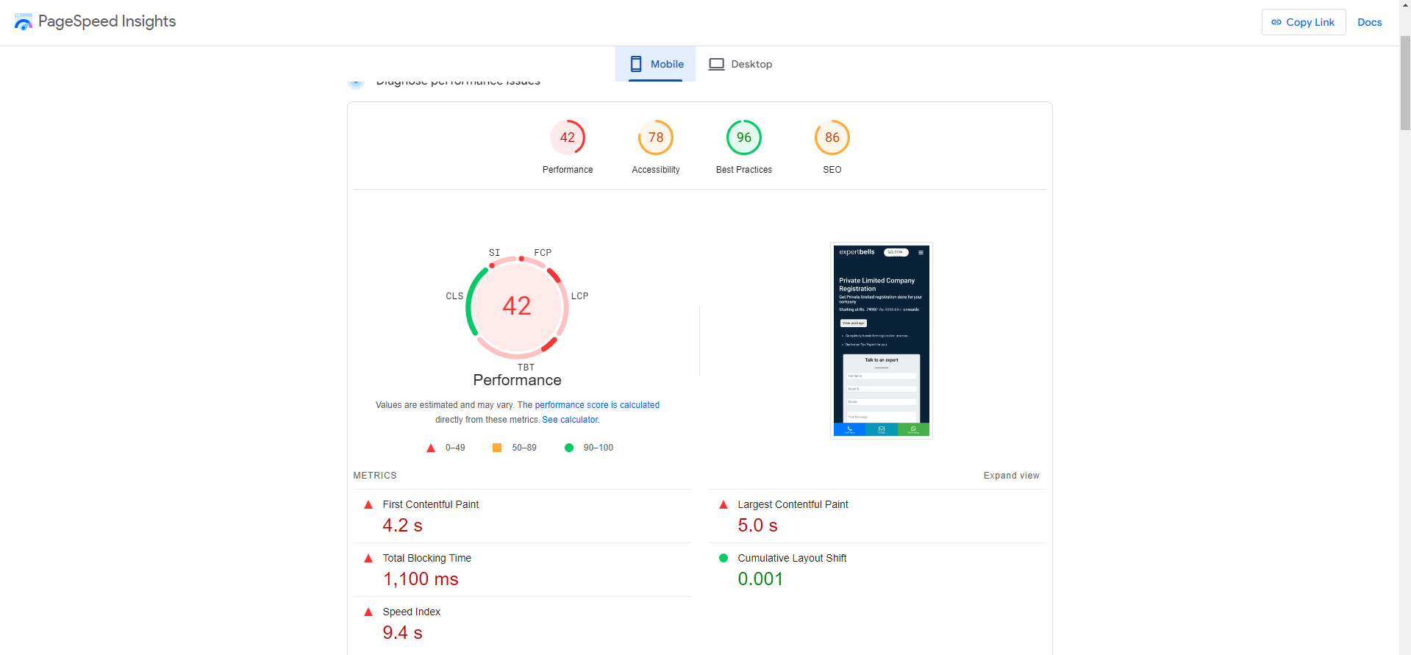

4)
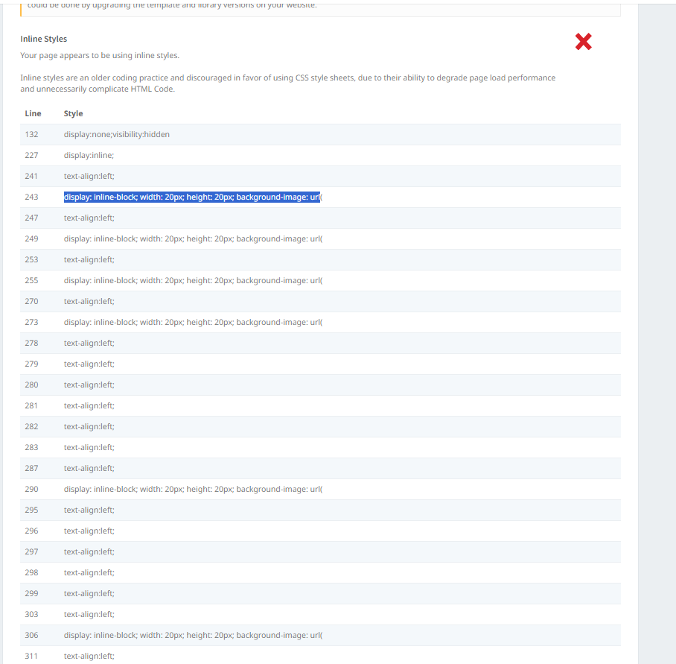

10)
